CENWP-OD-B 24 June 2024
MEMORANDUM FOR THE RECORD 24BON014 Cascades Island LPS Lamprey Mortalities

SUBJECT: 24BON014 MFR Cascades Island LPS Lamprey Mortalities

On the morning of 23 June, Project Biologists discovered that the Cascades Island Lamprey Passage System (LPS) was overflowing from the “pond” (Figure 1). The screen in the lamprey resting box that flows into the intake of the downstream section of the LPS had become clogged with debris. (Figure 2) The water was flowing freely from the top of the rest box which moved the lid and allowed Pacific Lamprey to escape. When Biologists happened upon this area, they noticed around 30 Lamprey on the ground. After cleaning the screen water levels reduced to normal levels inside of the LPS and the surviving lamprey were placed back into the rest box. There were 21 lamprey mortalities on 23 June (Figure 3), as well as 4 more mortalities found the morning of 24 June. (Figure 4&5)

Sporadic alarms had come in on the Fishway PLC for the west lamprey upwelling box as early as 18 June without Project Fisheries being notified. Several repeating alarms for this box came in between 0130 on 22 June and 0300 on 23 June. Unfortunately, the alarms were regarded as nuisance alarms during these occurrences and no physical checks were made on the LPS at the time of the alarms. The upwelling box and pond are checked daily for lamprey mortalities and nothing unusual was found during these inspections. This problem has not surfaced in the past, and with not finding any unusual water flow, neither Project Fisheries or Operations thought to clean the screen separating the pond and intake.

- Species – Pacific Lamprey (Entosphenus tridentatus)
- Origin – Unknown
- Length – (Figure 3) 61-71 cm. (Figure 4) In ascending order 69.9 cm, 64.1 cm, 59.7 cm. (Figure 5) 67.3 cm
- Marks and tags – None
- Marks and Injuries found on carcass – None
- Cause and Time of Death – June 23 and 24th
- Future and Preventative Measures –
  - Routine cleaning of screen separating the pond and the intake of downstream LPS section.
  - Install a screened overflow drain on the pond.
  - Alarm Diligence.

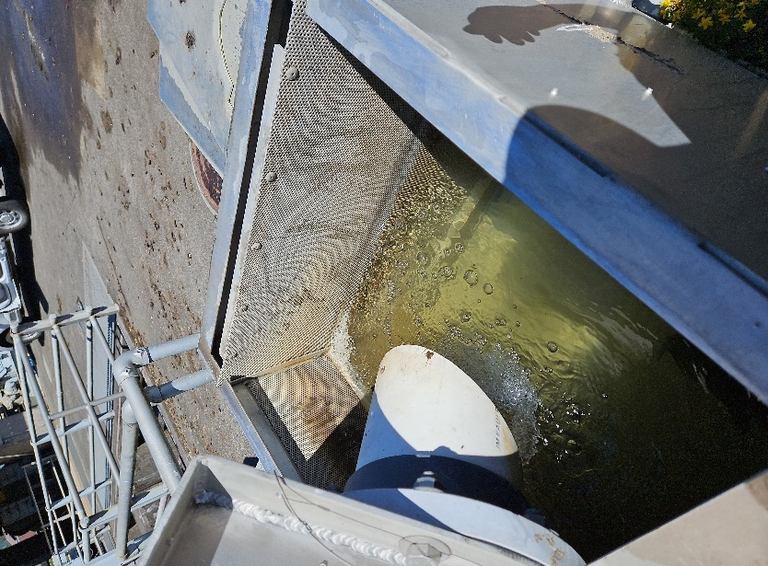
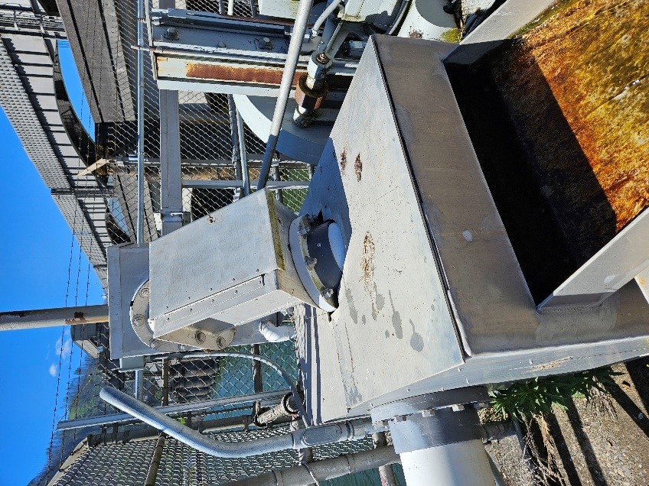
Figure 1
Figure 2

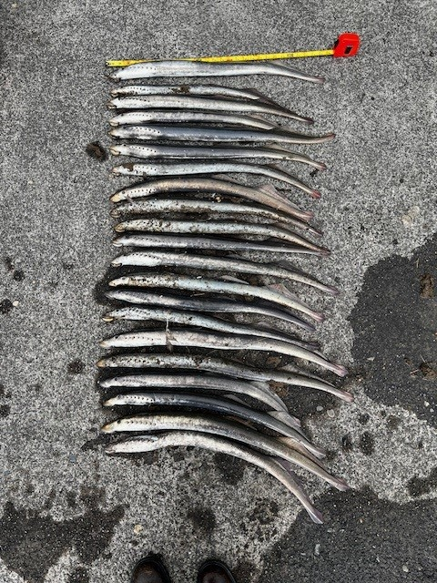
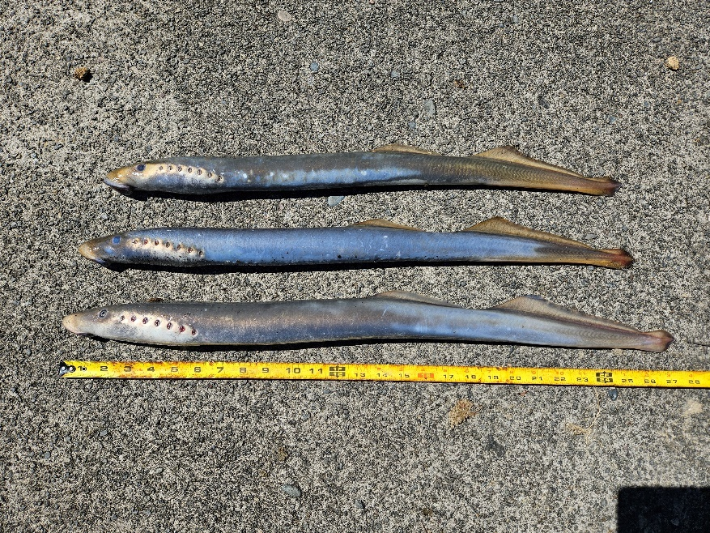
Figure 3
Figure 4

Figure 5
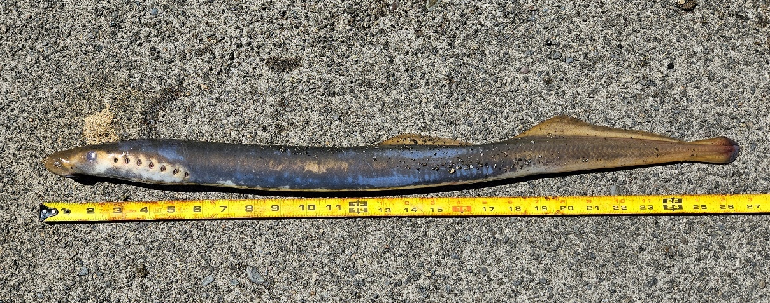

Sincerely,
Project Fisheries

